H.T No
Regulations:
A18

Sreenidhi Institute of Science and Technology
(An Autonomous Institution)
Code No: 7BC03 Date: 24-Mar-2023 (AN)

B.Tech I-Year I- Semester External Examination, March/April-2023 (Supplementary)
ENGINEERING MECHANICS (ME)

Time: 3 Hours Max.Marks:70

Note: a) No additional answer sheets will be provided.
b) All sub-parts of a question must be answered at one place only, otherwise it will not be valued.
c) Missing data can be assumed suitably.
Bloom's Cognitive Levels of Learning (BCLL)

Remember | L1 | Apply | L3 | Evaluate | L5
Understand | L2 | Analyze | L4 | Create | L6

Part - A Max.Marks:20

Answer all QUESTIONS.

 |  | BCLL | CO(s) | Marks
1 | State parallelogram law. | L1 | CO1 | [2M]
2 | What are the assumptions of a perfect truss? | L1 | CO2 | [2M]
3 | Write an expression for centroid of the following areas (i) Triangle (ii) Semicircle | L2 | CO3 | [2M]
4 | State the Parallel Axis Theorem. | L1 | CO4 | [2M]
5 | Define the terms (i) Kinematics (ii) Kinetics | L1 | CO5 | [2M]
6 | State the principle of conservation of energy. | L1 | CO6 | [2M]
7 | State Varignon's theorem, | L1 | CO2 | [2M]
8 | Describe the following terms : (i) Limiting friction (ii) Coefficient of friction | L2 | CO3 | [2M]
9 | State D'Alembert's principle | L1 | CO5 | [2M]
10 | Define impulsive force ? | L1 | CO6 | [2M]

Part – B Max.Marks:50
ANSWER ANY FIVE QUESTIONS. EACH QUESTION CARRIES 10 MARKS.

 |  |  | BCLL | CO(s) | Marks
11. | a) | Find the resultant of the force acting on a particle P shown in Fig.11(a)  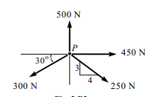  Fig. 11(a) | L3 | CO1 | [5M]
 | b) | Determine completely the resultant of the four forces shown in Fig.11(b). Each force makes an 15^{O} angle with the vertical except the 2000 N force which is vertical.  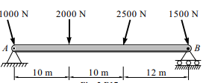  Fig 11(b) | L3 | CO1 | [5M]
12. |  | Find the forces in all the members of the truss shown in Fig.12(a)  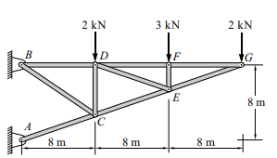  Fig.12(a) | L3 | CO2 | [10M]
13. | a) | Two blocks A and B weighing 500N and 1000N respectively, are resting against a wall and the floor as shown fig.. Find the value of the horizontal force P applied to the lower block that will hold the system in equilibrium. Coefficients of friction are 0.25 at the floor and wall and 0.2 between the blocks. | L4 | CO3 | [5M]
 | b) | Find the centroid of the following shaded plane area shown in the Fig.  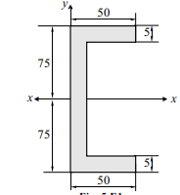 | L3 | CO3 | [5M]
14. | a) | Derive the equation for moment of inertia of circular plate of radius R and thickness t about the centroidal axis. | L3 | CO4 | [5M]
 | b) | Derive the expression for mass moment of inertia of a right circular cylinder. | L3 | CO4 | [5M]
15. | a) | A particle travels along a straight line path such that in 4 sec it moves from an initial position S = -8 m to position S = +3 m. Then in another 5 sec it moves from S to S = -6 m. Determine the particle's average velocity and average speed during 9 sec interval. | L3 | CO5 | [5M]
 | b) | A 50 kg block kept on the top of a 15 sloping surface is pushed down the plane with an initial velocity of 20 m/s. If m = 0.4, determine the distance travelled by the block and the time it will k take as it comes to rest. | L3 | CO5 | [5M]
16. |  | A mass of 20 kg is projected up an inclined of 26 with velocity of 4 m/s, . If m = 0.2, (i) find maximum distance that the package will move along the plane and (ii) What will be the velocity of the package when it comes back to initial position ?  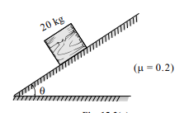 | L3 | CO6 | [10M]
17. | a) | Discuss the various types of equilibrium. | L2 | CO1 | [5M]
 | b) | State the laws of friction | L1 | CO2 | [5M]
18. | a) | Derive an expression for MI of Triangle About its Base | L5 | CO4 | [4M]
 | b) | A man weighing W Newton entered a lift which moves with an acceleration of a m/sec² , Find the force exerted by the man on the floor of the lift when lift is moving downward. | L3 | CO5 | [3M]
 | c) | State the principle of conservation of momentum | L1 | CO6 | [3M]

-- 00 -- 00 –

